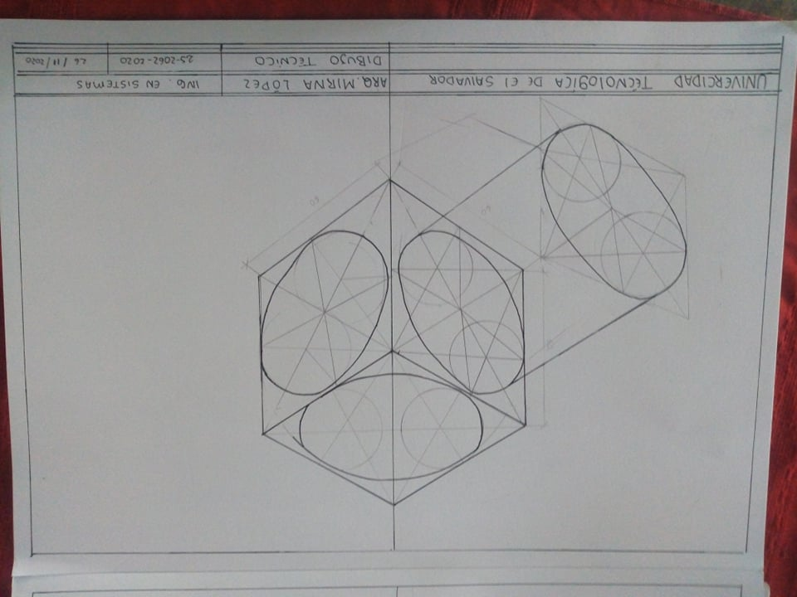Dueñas molina krissia magali 2520622020